## 

## 

## 

## 

## 

Statistical analysis of lead level testing in flint school systems pre and post fixtures

EPH 505: Biostatistics III

Yale School of Public Health

Rei Marshall

**Introduction**

In 2014, the city of Flint, Michigan drew national attention after its water supply was contaminated with lead and bacteria due to pipe corrosion after the city switched to the Flint River as a source of drinking water (CDC, 2024). Despite the return to the original water source, the damaged pipes continued to leak lead into the drinking water. The emergency greatly harmed the city of Flint’s large population of low-income and African American residents, two demographic groups with historical health disparities at baseline conditions (Kennedy, 2016). Children, who are particularly susceptible to lead poisoning, were majorly affected; which is why accessible clean water in schools became a priority. The lead content in the water, in parts per billion ( ppb), was recorded before new pipes, after the installation of new pipes, and after the installation of a filter, in order to determine the efficacy of the individual phases as well as the complete project.

## **Methods**

School testing data from a 2015 through 2016 study, pre and post fixture, was acquired from the Healthy Flint Research Center. R statistical software (Bell Laboratories, NJ), an open source statistical and graphics software, was used to visualize lead and copper levels pre-pipe fixture, post-pipe fixture, and post-filter fixture. A t-test was inferentially used to determine the difference between the means of pre fixtures and post interventions (post-pipes and post-filters).

## **Results**

A t-test comparing lead levels before the intervention [pre-fix] (0.014 mg/L) to post-pipe replacement (0.013 mg/L) showed no significant difference (p = 0.75). However, comparing pre-fix lead levels to those after filter installation (0.023 mg/L) revealed a significant increase (p = 0.02). For copper, a t-test found no significant difference between pre-pipe (0.26 mg/L) and post-pipe (0.25 mg/L) levels (p = 0.55), while post-filter copper levels (0.30 mg/L) were significantly higher than pre-intervention levels (p = 0.025). Comparing mean lead levels by school across three time points—pre-fix, post-pipes, and post-filter—we found that 'Holmes STEM Academy' showed the greatest improvement in lead levels post-fix (mean difference = 0.033 mg/L), followed by 'Michigan School for the Deaf & Learning' (mean diff = 0.013 mg/L). For copper, 'Brownell STEM Academy' had the best post-fix results (mean difference = 0.104 mg/L), followed by 'Holmes STEM Academy' following (mean diff = 0.047 mg/L). Holmes STEM Academy's zip code (48504) showed the greatest lead reduction post-fix (mean diff = 0.015 mg/L), while Michigan School for the Deaf and Learning Center's zip code (48503) had the best copper reduction (mean diff = 0.108 mg/L).

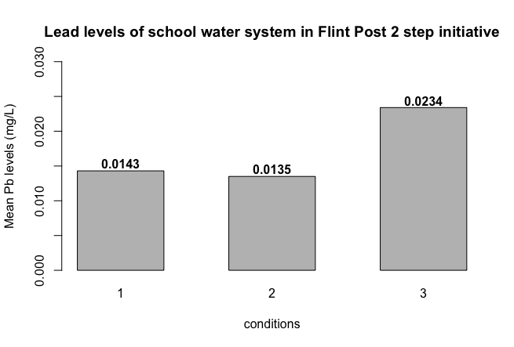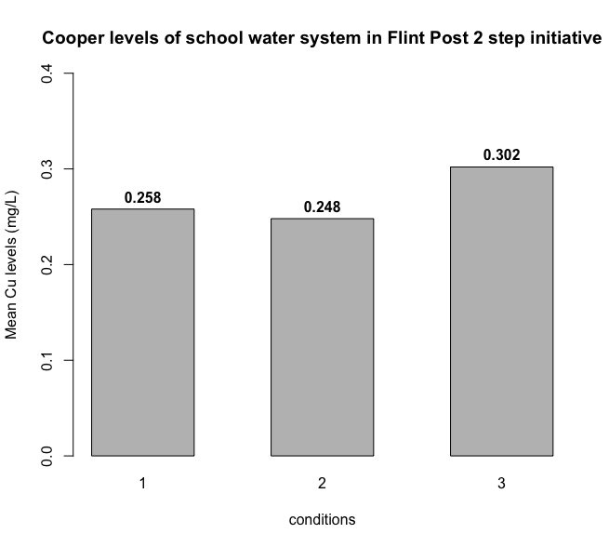

**Fig. 1.** Overall mean Lead (Pb) and Cooper (Cu) levels in Flint school water systems pre(1), replacement of pipes(2), and filter placements (3).

## **Discussion**

The new fixtures and filters appear to have had no positive impact on the quantity of lead in the Flint schools’ water. The lead levels (in ppb) continued to increase, though there is no evidence that the increase was *due to* the intervention; a more likely explanation is that the lead continued accumulating in Flint’s water supply and the new pipes and filters failed to stop this increase. While many of the more modern buildings in the United States use copper pipes, the low-income city of Flint still relies on older lead pipes (Dingle, 2016). The copper levels in the data set function as a control variable and a comparison between older and more modern buildings, as the copper pipes did not leak dangerous levels of chemicals into the water supply. Though many schools were only tested pre-fixture and lost from follow-up, the general trend implies that Flint’s schools still are without clean drinking water, regardless of the new interventions. The findings are unsurprising, given that the city of Flint is known to still have unsafe drinking water in 2024 (Nelson, 2024).

## References

“Story: Flint Water Crisis | CASPER.” *CDC*, 8 April 2024, https://www.cdc.gov/casper/php/publications-links/flint-water-crisis.html. Accessed 18 September 2024.

Kennedy, Merrit. “Lead-Laced Water In Flint: A Step-By-Step Look At The Makings Of A Crisis.” *NPR*, 20 April 2016, https://www.npr.org/sections/thetwo-way/2016/04/20/465545378/lead-laced-water-in-flint-a-step-by-step-look-at-the-makings-of-a-crisis. Accessed 18 September 2024.

Nelson, Bria. “Ten Years Later, Flint Still Doesn't Have Clean Water.” *Human Rights Watch*, Newsweek, 20 May 2024, https://www.hrw.org/news/2024/05/20/ten-years-later-flint-still-doesnt-have-clean-water?gad_source=1&gclid=Cj0KCQjw3bm3BhDJARIsAKnHoVW8KHCbbBl9ioQTKkxPLreDYEkPmlcW54Dq2Ff82atX1G8g1SF6imMaAvyUEALw_wcB. Accessed 21 September 2024.

Dingle, Adrian. “The Flint Water Crisis: What's Really Going On?” *American Chemical Society*, https://www.acs.org/education/chemmatters/past-issues/2016-2017/december-2016/flint-water-crisis.html. Accessed 21 September 2024.